Student Name: Ravi Kumar
Student ID: 11716666 (B40)
Email Address: ravikumargupta7676744@gmail.com
GitHub Link: https://github.com/Ravikumar962/SJF-non-preemptive-sheduling-in-c

Problem:
Ques17. Design a scheduler following non-preemptive scheduling approach to schedule the processes that arrives at different units and having burst time double the arrival time. Scheduler selects the process with largest burst time from the queue for the execution. Process is not being preempted until it finishes its service time. Compute the average waiting time and average turnaround time. What should be the average waiting time if processes are executed according to Shortest Job First scheduling approach with the same attribute values.

Ans:
Algorithm:
Step 1: Start
Step 2: Ask the user to enter no. of processes.
Step 3: Accept the number of processes in the ready Queue along with the arrival time.
Step 4: Calculate Burst time as according to question burst time is twice of ariavl time.
Step 5: Arrange the details given in tabular form, processes with their arrival time and burst time.
Step 6: Prepare Gantt chart and arrange processes with their arrival time and state of entering to get process as according to question processing is done according to burst time in high priority.
Step 7: Calculate
(a) Waiting time for process(n) = waiting time of process(n-1)+ burst time of process(n-1 ) + the time difference in getting the CPU from process(n-1)
(b) Turn around time for process(n) = waiting time of process(n) + burst time of process(n)+ the time difference in getting CPU from process(n).
Step 8: Calculate
(a) Average waiting time = Total waiting Time / Number of process
(b) Average Turnaround time = Total Turnaround Time / Number of process
Step 9: Stop

Description:
In this code first we1 ask user to enter no. of processes after entering total no. of processes, their arrival time and according to arrival time we calculate burst time then we prepare Gantt chart and process enters into the chart according to its arrival time and burst time, then we calculate Completion time and then after Turn around time and Waiting time after calculating waiting time and turn around time for all processes we calculate average of waiting time and turn around time.

Time Complexity: O(n^2).

Code:
//Question no -17 Ravi Kumar B40
#include<stdio.h>
int main()
{
int i,n,p[10]={1,2,3,4,5,6,7,8,9,10},min,k=1,btime=0;
int bt[10],temp,j,at[10],wt[10],tt[10],sum1=1,sum=0,ct[10];
float wavg=0,tavg=0,tsum=0,wsum=0;
printf("Enter the No. of processes :\n");
scanf("%d",&n);

for(i=0;i<n;i++)
{
printf("Enter the Arrival time of p%d process :\n",i+1);
scanf("%d",&at[i]);
printf("Brust time of p%d process :\n",i+1);
printf("%d\n",bt[i]=2*at[i]);
}

/*Sorting According to Arrival Time*/

for(i=0;i<n;i++)
{
for(j=0;j<n;j++)
{
if(at[i]<at[j])
{
temp=p[j];
p[j]=p[i];
p[i]=temp;
temp=at[j];
at[j]=at[i];
at[i]=temp;
temp=bt[j];
bt[j]=bt[i];
bt[i]=temp;
}
}
}

for(j=0;j<n;j++)
{
btime=btime+bt[j];
min=bt[k];
for(i=k;i<n;i++)
{
if (btime>=at[i] && bt[i]<min)
{
temp=p[k];
p[k]=p[i];
p[i]=temp;
temp=at[k];
at[k]=at[i];
at[i]=temp;
temp=bt[k];
bt[k]=bt[i];
bt[i]=temp;
}
}
k++;
}
wt[0]=0;
sum=1;
ct[0]=1;
for(i=1;i<=n;i++)
{
if(at[i-1]==0)
sum=sum+1;
sum=sum+bt[i-1];
ct[i-1]=sum;
tt[i]=ct[i-1]-at[i-1];
tsum=tsum+tt[i];
wt[i]=tt[i]-bt[i-1];
wsum=wsum+wt[i];
}

wavg=(wsum/n);/*
for(i=0;i<n;i++)
{
sum1=sum1+bt[i];
tt[i]=sum-at[i];
tsum=tsum+tt[i];
}*/

tavg=(tsum/n);

printf("******************************************************");
printf("\n\t\t\t\t\t\t\t RESULT:-");
printf("\n\t\t\t\t\t Shortest Job First,Non-Preemptive\n\n");
printf("\n\t\t------------------------------------------------------------------------------------");
printf("\n\t\t| Process |\tBT\t|\tAT\t|\tWT\t|\tTAT\t|\tCT\t|" );
printf("\n\t\t------------------------------------------------------------------------------------");
for(i=0;i<n;i++)
{
printf("\n\t\t| p%d\t |\t%d\t|\t%d\t|\t%d\t|\t%d\t|\t%d\t| ",p[i],bt[i],at[i],wt[i+1],tt[i+1],ct[i]);
}
printf("\n\t\t------------------------------------------------------------------------------------");

printf("\n\n\n*************************************************************");
printf("\n\t\t\t\t ..Order of execution according to Gantt chart..\n");

printf("\n");

printf("\t\t\t\t\t--------------\n\t\t\t\t\t");

for(i=0;i<n;i++)
{
printf("| Process[%d] |\n\t\t\t\t\t",p[i]);
}
printf("--------------\n\t\t\t\t\t");
printf("\n\n\n\nAVERAGE WAITING TIME : %f",wavg);
printf("\nAVERAGE TURN AROUND TIME : %f",tavg);
return 0;
}

Output:
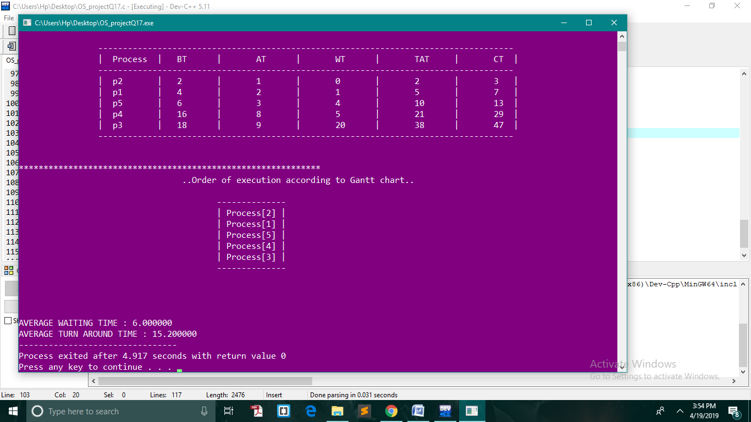

Test Cases:-

Test case 1:
FOR 4 PROCESSES-

Arrival time of process 1:2
Burst time of process 1:4

Arrival time of process 2:1
Burst time of process 2:2

Arrival time of process 3:3
Burst time of process 3:6

Arrival time of process 4:4
Burst time of process 4:8

Process Burst Arrival Waiting Turn-around-time completion time
p2 2 1 0 2 3
p1 4 2 1 5 7
p4 6 3 4 10 13
p3 8 4 9 17 21

Average Waiting time = 10.0000
Average Turn around time = 47.6666

Test case 2:
FOR 5 PROCESSES-

Arrival time of process 1:2
Burst time of process 1:4

Arrival time of process 2:1
Burst time of process 2:2

Arrival time of process 3:9
Burst time of process 3:18

Arrival time of process 4:8
Burst time of process 4:16

Arrival time of process 5:3
Burst time of process 5:6

Process Burst Arrival Waiting Turn-around-time completion time
p2 2 1 0 2 3
p1 4 2 1 5 7
p5 6 3 4 10 13
p4 16 8 5 21 29
p3 18 9 20 38 47

Average Waiting time = 5.20000
Average Turn around time = 10.40000

